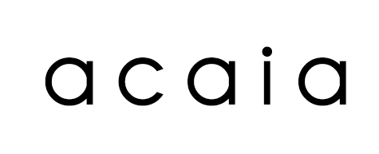

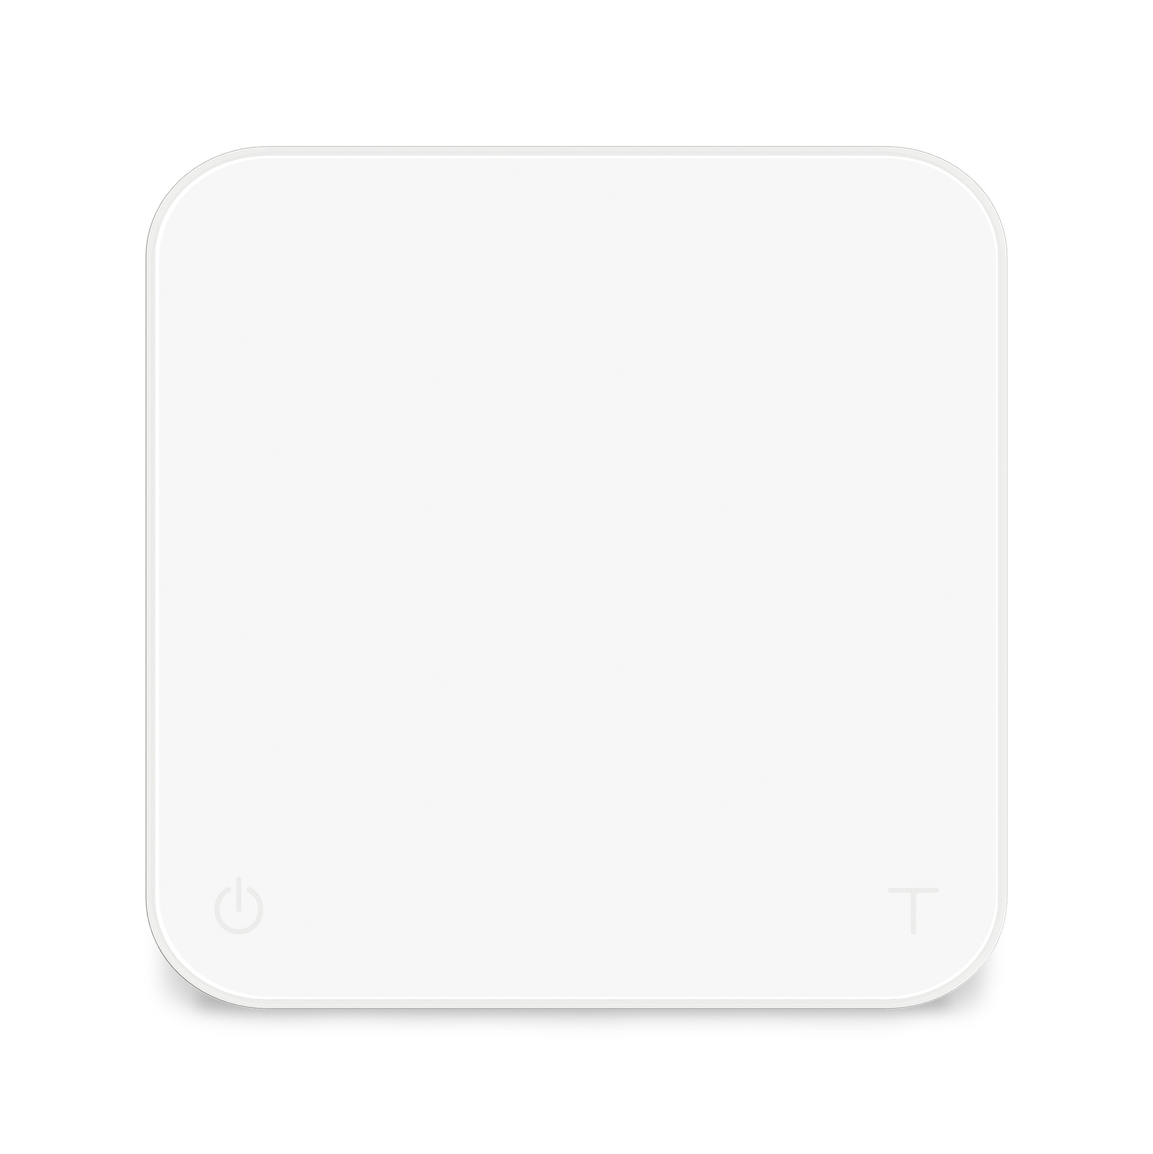

Acaia Pearl Model S User Manual

PS003 / PS004

FW 1.0.005

Contents

3 | In the Box
3 | Introduction
3 | Scale Overview
4 | Getting Started
4 | Placement
4 | Power On / Off
4 | Tare Weight
4 | Switch between Grams / Ounces
4 | Switch Modes
5 | Product Care Information
5 | Battery Charge
5 | Battery Level Indicator
5 | Calibration
6 | Using the Acaia Brewguide
6 | Using Brewguide for the First Time
6 | Using Brewguide on Pearl Model S
7 | Sound Notification
8 | Mode Introduction
8 | Mode 1 – Weighing Only Mode
8 | Mode 2 – Dual Display Mode
9 | Mode 3 – Pour-Over Auto-Start Timer Mode
10 | Mode 4 – Portafilter Mode
11 | Mode 5 – Espresso Mode
12 | Mode 6 – Flowrate Mode
12 | Mode 7 – Brewguide Mode
13 | Mode 8 – Countdown Mode
14 | Configuration
20 | Appendix
20 | Buttons
21 | LED Indicators
22 | Error Codes
22 | Other
23 | Specifications

In the Box

Introduction
Thank you for choosing one of our scales. The Acaia Pearl Model S is designed and manufactured to the most rigorous standard to give you the best coffee brewing experience. First, check the shipping carton to find the following:

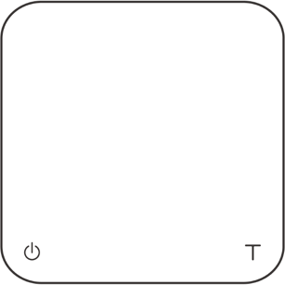
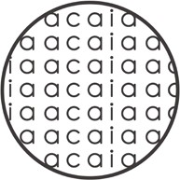
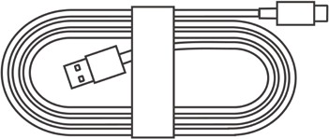

Acaia Pearl Model S Coffee Scale
Heat Resistant Coaster USB Type-C Charging Cable

Next, follow the instructions in the “Getting Started” chapter in this manual to start using your scale. To take full advantage of the many features of the Pearl Model S, carefully read through this user manual for step-by-step procedures, examples, and other information.

Warning: Incorrect handling of this product could result in personal injury or physical damage.

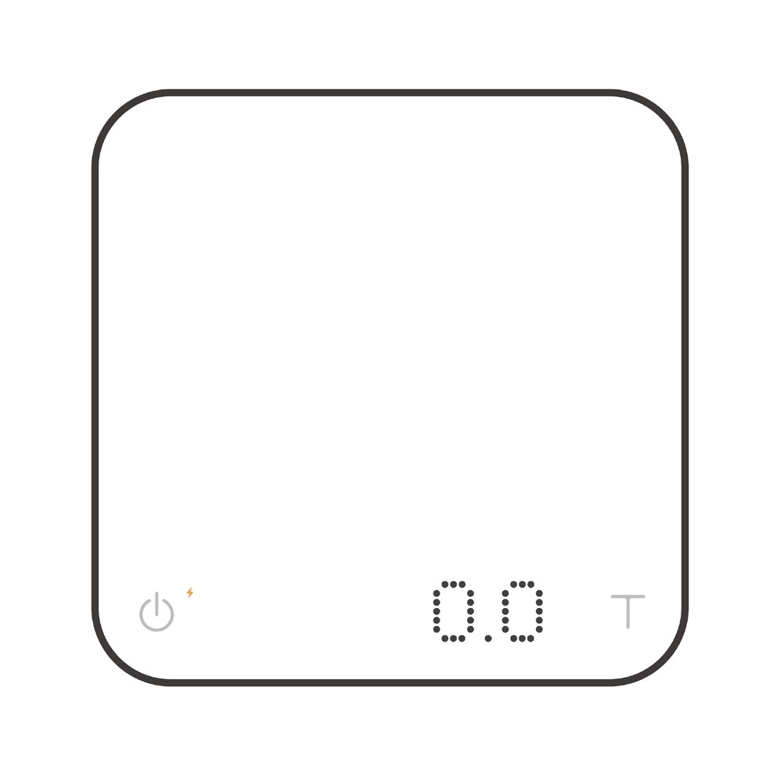Scale Overview

Weighing Pan

Charging / Low Battery
Indicator
LED Display

Power Button Tare Button

*Note: For the best performance, place the weight in the center of the weighing pan.

Getting Started

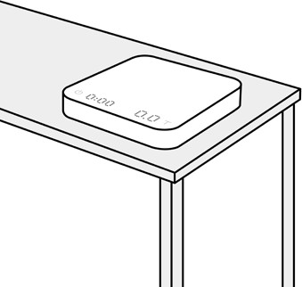
Placement

Select a work surface that is stable, vibration-free and level to place the scale.

Power On / Off

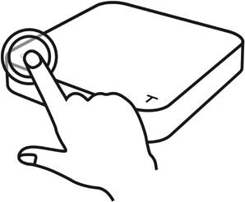
Tap the Power button to turn on the scale. Double tap the Power button to turn off the scale.

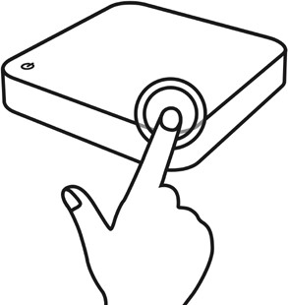
Tare Weight

Tap the Tare button to tare / zero the weight.

Switch between Grams / Ounces
Press and hold the Tare button to switch between grams / ounces.

Switch Modes

Press and hold the Power button to switch modes.

* Please see the “Mode Introduction” section for more details.

Product Care Information

Battery Charge

- You can charge the battery by plugging the USB cable into any of the power supplies listed below:
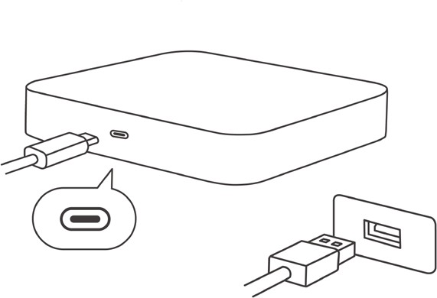
  - A computer
  - A USB wall-charger with an output of 5 volts and 1 amp
  - A DC car-charger with an output of 5 volts and 1 amp
  - A USB-C PD charger supporting 5 volts
- It takes about 3-4 hours to fully charge the battery from empty. Try not to let the battery completely run out before charging. Charge the battery as needed.
- A fully charged battery can provide up to 16 hours of working time in normal brightness and up to 40 hours in low brightness mode.
- To check remaining battery level, see “Battery Level Indicator” section.
* Note: The Acaia Pearl Model S is equipped with charging protection to prevent the battery from charging under high temperatures. It is normal if the scale does not charge when the surface is hot from brewing coffee. Battery charging function will be enabled once the scale has cooled.

Battery Level Indicator
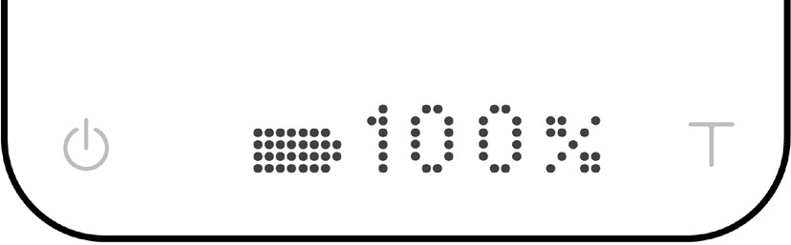
- When the Pearl Model S is powered off, press and hold the Power button. The LED will display [ acaia ], [ Settings ], and then the battery percentage.
- You can also check the battery level by connecting the Pearl Model S to Acaia Apps.

Calibration

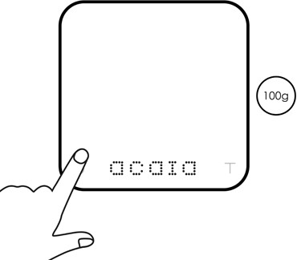
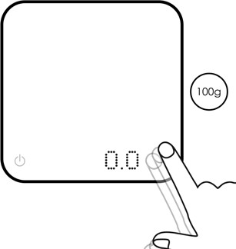
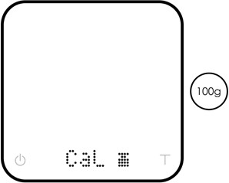
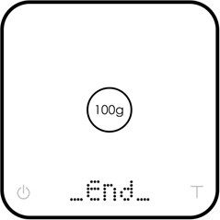

Turn on scale Tap Tare button See CaL display Place a weight

Turn to Weighing Mode, with the unit set to ‘grams’.
Rapidly tap the Tare button until ‘CaL’ is shown on the
display.
Place an Acaia or F2 class standard weights on the scale (100 g / 500 g /
1000 g / 2000 g).
When the display show ‘_End_’.
Calibration is now complete!

Using the Acaia Brewguide

Using Brewguide for the First Time
Brewguide is a step-by-step interactive guide to brewing coffee. Simply scan the Acaia Brewguide QR code on the coffee bean bag, and use the Acaia Brewguide app to download the recipe to your Pearl Model S. In the Brewguide app, you can also discover guides created by roasters around the world.

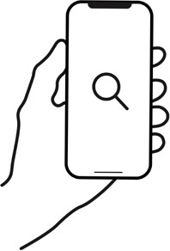
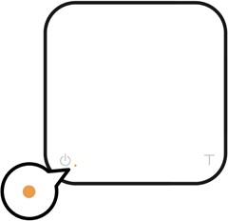
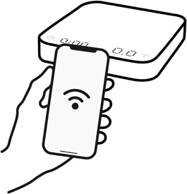

Download
Download the Brewguide app

Connect
Activate Bluetooth on your phone and connect with the Pearl Model S

Start personalization
Follow the instructions on the Brewguide app

Using Brewguide on Pearl Model S

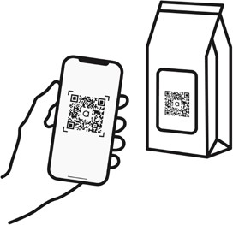
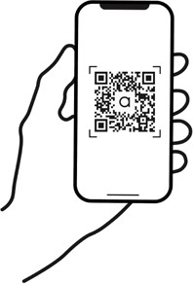
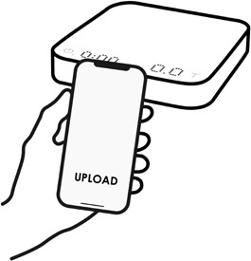

1
Search or scan the QR Code to find the Brewguide you need.
2
Select a brewguide.
3
Choose “Upload to Pearl S” in the app to send it to the Pearl Model S.

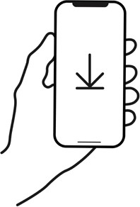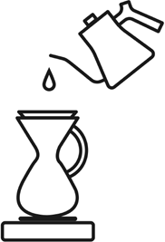

4
Wait until the Brewguide is sent to the Pearl Model S; this may take up to one minute.
5


Follow the guide and get brewing!

Sound Notification

Personalize Sound Notification
The Pearl Model S comes with sound notification to enhance your brewing experience. Hear the weight and time notified at fixed intervals to help you focus on your brewing workflow.
You can further personalize Sound Notifications with the choices of voice, sound effect, or turn it off in Advanced Settings:

Timer Notification Sound

Enter Settings Menu and look for [ Timer Notification Sound ] setting. Available options for this setting:

Sound | The scale notifies with sound effect as a reminder every 10 seconds and 60 seconds once the timer is started.
Voice | The scale reads out the time every 10 seconds once the timer is started.
Off (default) | Sound Notification for timer disabled.
Timer Notification Sound is supported in Dual Display Mode, Espresso Mode, Pour-Over Auto-Start Timer Mode, and Flowrate Mode.

Weight Notification Sound

Enter Settings Menu and look for [ Weight Notification Sound ] setting. Available options for this setting:

Sound | When a flow detected, the scale beeps as a reminder every 20 grams or the equivalent at every 0.7 ounces.
Voice | When a stable weight is detected, the scale reads out the weight. When a flow is detected, the scale reads out weight increment every 20 grams or the equivalent at every 0.7 ounces.
Off (default) | Sound Notification for weight disabled.
Weight Notification Sound is supported in Weighing Only Mode, Dual Display Mode, Espresso Mode, Pour-Over Auto-Start Timer Mode, and Flowrate Mode. Please note that the “Sound” option is not supported in Weighing Only Mode.

Sound Notification Priorities

- When the Timer and Weight are both set to Voice, if there is an overlap in notification, the Pearl Model S will prioritize and announce the Weight first, then the Time.
- When the Timer and Weight are both set to Sound, if there is an overlap in notification, the Pearl Model S will prioritize the Time and omit the Weight notification.
- When the Timer is set to Sound, and Weight is set to Voice, if there is an overlap in notification, the Pearl Model S will prioritize the Time, and omit the Weight notification.

Mode Introduction

Mode 1 - Weighing Only Mode

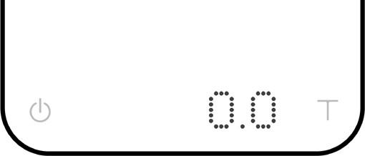
In the Weighing Only Mode, the scale will only display weight, in either grams or ounces.

  - There are two different weighing units in Weighing Only Mode: grams and ounces. A green dot will appear in the upper right of the LED display and the scale will read 0.000 when weighing in ounces.
  - The LED display shows [ 0.0 ] when the scale is measuring in grams.
  - The LED display shows [ 0.000 ] when the scale is measuring in ounces.
  - The readability is 0.1 g for grams and 0.005 oz for ounces.

Action | Operation
Tare Weight | Tap Tare button
Switch between Grams / Ounces | Press and hold Tare button
Reset Mode | Double tap Tare button
Switch Mode | Press and hold Power button

Mode 2 - Dual Display Mode

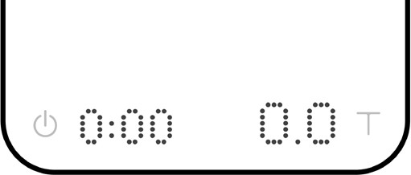
In the Dual Display Mode, the scale displays [ 0:00 0.0 ] with a timer (left) and weight (right).

  - There are two different weighing units in Dual Display Mode: grams and ounces.
  - The LED display shows [ 0:00 0.0 ] when the scale is measuring in grams.
  - The LED display shows [ 0:00 0.000 ] when the scale is measuring in ounces.
  - When the weight exceeds 999 grams, the LED display only shows the integer part (the decimal point will not be displayed). The LED display shows up to a maximum of 3000 grams. If the weight exceeds 3000 grams, the scale will display [ Maximum ].

Action | Operation
Start / Stop / Reset Timer | Tap Power button
Tare Weight | Tap Tare button
Reset Mode | Double tap Tare button
Switch between Grams / Ounces | Press and hold Tare button
Switch Mode | Press and hold Power button

Mode 3 - Pour-Over Auto-Start Timer Mode

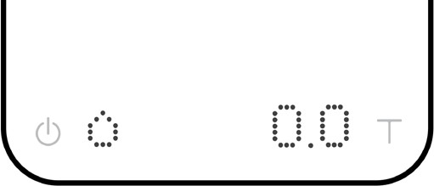
The Pour-Over Auto-Start Timer Mode is designed to aid pour-over coffee brewing. The scale will detect the start of the flow from kettle into the vessel and automatically start the timer function; the timer stops when the brewing equipment has been removed
from the scale. When the vessel is removed from the scale, the display flashes the final
beverage weight.

Display
  - The LED display flashes [ 0.0 ] and [ 0:00 0.0 ] when measuring in grams and the timer is idle.
  - The LED display flashes [ 0.000 ] and [ 0:00 0.000 ] when measuring in ounces and the timer is idle.
  - Once the timer has started, the LED display shows [ 0:00 0.0 ], with the time elapsed on the left and the weight on the right in grams.
  - Once the timer has started, the LED display shows [ 0:00 0.000 ], with the time elapsed on the left and the weight on the right in ounces.
  - When the weight exceeds 999 grams, the LED display only shows the integer part (the decimal point will not be displayed). The LED display shows up to a maximum of 3000 grams. If the weight exceeds 3000 grams, the scale will display [ Maximum ].

Mode Description
  - If the timer has not started yet, the display will flash 0:00 and a water droplet.
  - The timer will start automatically when the first flow of water is detected.
  - The timer stops when the brewing equipment is removed. The scale will flash between the beverage weight and the tare weight of the items on the scale.

Action | Operation
Start / Stop / Reset Timer | Tap Power button
Tare Weight | Tap Tare button
Reset Mode | Double tap Tare button
Switch between Grams / Ounces | Press and hold Tare button
Switch Mode | Press and hold Power button

Mode 4 - Portafilter Mode

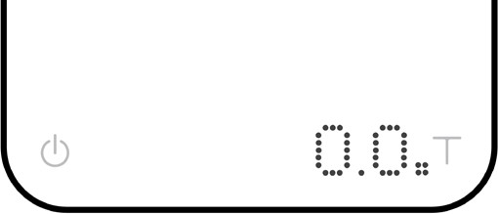
The Portafilter Mode is designed to speed up the workflow of accurately weighing coffee grounds in a portafilter. The scale automatically tares the portafilter and allows for the adjustment of the ground coffee. The mode will reset 15 seconds after removing the portafilter to enable weighing for the next shot.

Display
  - When measuring in grams, the display shows [ 0.0 ] before a portafilter is placed on the scale.
  - When measuring in ounces, the display shows [ 0.000 ] before a portafilter is placed on the scale.
  - The display shows [ 0.0 ] / [ 0.000 ] after a portafilter has been registered.

Mode Description
  - Place an empty portafilter on the scale, and the scale will register the weight of the portafilter.
  - Remove the portafilter after [ ] disappears.

Action | Operation
Tare Weight | Tare function begins automatically when a stable weight is placed on the scale
Reset Mode | Double tap Tare button
Switch between Grams / Ounces | Press and hold Tare button
Switch Mode | Press and hold Power button

Note
- If the scale is left idle for 15 seconds or you double tap the Tare button, the Pearl Model S will automatically reset the mode to default for the next auto-tare operation.
- To change the timer reset length in Portafilter Mode, see the “Configuration” section (p.14- 15).

Mode 5 - Espresso Mode

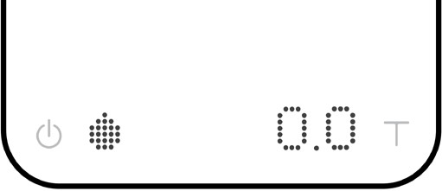
This mode is designed to aid espresso extraction. The scale automatically tares the weight of the vessel. It will then detect the start of the flow of espresso into the vessel and automatically start the timer function; the timer stops when the flow of espresso into the vessel stops.

Display
  - The LED display flashes [ 0.0 ] and [ 0:00 0.0 ] when measuring in grams and the timer is idle.
  - The LED display flashes [ 0.000 ] and [ 0:00 0.000 ] when measuring in ounces and the timer is idle.
  - When the weight exceeds 999 grams, the LED display only shows the integer part (the decimal point will not be displayed). The LED display shows up to a maximum of 3000 grams. If the weight exceeds 3000 grams, the scale will display [ Maximum ].

Mode Description
  - When an object (such as a cup) weighing two grams or more is placed on the scale and the weight reading is stable, the scale will perform auto tare.
  - After the scale detects the flow of espresso, the timer will start. The timer will stop when the espresso flow stops.
  - When the espresso is ready and the cup is removed, the display will flash between the beverage weight and the vessel weight.

Action | Operation
Start / Stop / Reset Timer | Tap Power button
Tare Weight | Tap Tare button
Reset Mode | Double tap Tare button
Switch between Grams / Ounces | Press and hold Tare button
Switch Mode | Press and hold Power button

Note
- In Espresso Mode, the timer will stop when the espresso flow stops.
- The auto-tare function is performed only when the weight exceeds two grams.
- If you leave the scale idle for ten seconds, it will reset the timer and perform tare operation.
- In Espresso Mode, the timer will also stop when a negative weight (i.e., removal of a cup) is detected.

Mode 6 - Flowrate Mode

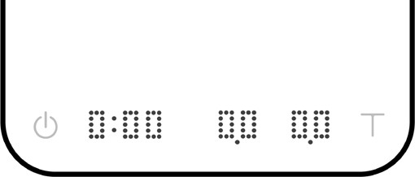Designed for pour-over coffee brewing. The display includes timer, weight, and flowrate.

Timer Weight Flowrate

  - The LED display shows [ 0:00 0.0 0.0 ] when the scale is measuring in grams.
  - The LED display shows [ 0:00 0.000 0.00 ] when the scale is measuring in ounces.
  - When the weight exceeds 999 grams, the LED display only shows the integer part (the decimal point will not be displayed). The LED display shows up to a maximum of 3000 grams. If the weight exceeds 3000 grams, the scale will display [ Maximum ].
  - The flowrate is measured in grams per second (g/s) on the right hand side of the display.

Action | Operation
Start / Stop / Reset Timer | Tap Power button
Tare Weight | Tap Tare button
Reset Mode | Double tap Tare button
Switch between Grams / Ounces | Press and hold Tare button
Switch Mode | Press and hold Power button

Mode 7 - Brewguide Mode

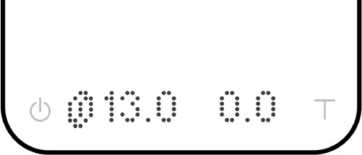
A step-by-step interactive guide to brewing coffee. Simply use the Acaia Brewguide app to download the recipe to your Pearl Model S. In the Brewguide app, you can also discover guides created by roasters around the world.

Note: Brewguide mode only supports display in grams.

Action | Operation
Go to the Next Step | Press and hold Tare button
Display Current Instruction Text Again | Tap Power button
Tare | Press Tare button
Switch Mode | Press and hold Power button

Mode 8 - Countdown Mode

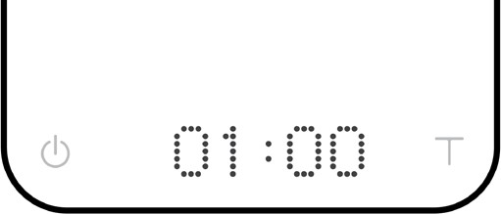
The Countdown Mode is a customizable timer. Personalize your timer with 3 adjustable presets and over 30 melodious tones. Note that only one timer can be active at the same time.

You can further customize the countdown timer by enabling / disabling periodic reminders and choose if you would like the timer to continue counting with negative value after the time is up.

Mode Description
  - Press and hold Tare button until the minutes start blinking to adjust the timer. Tap Tare button to increase the current value. Press and hold Tare button to scroll faster. Tap Power button to confirm. Minimum time setting for the countdown timer is 00:10.
  - Tap Power button to switch between the three timer presets.
  - Refer to the [ Ringtone ], [ Continue Timer Countdown ], and [ Periodic ] section in Advanced Settings Menu to further personalize your timer.

Action | Operation
Start / Stop / Reset Timer | Press Tare button
Timer Adjustment | Press and hold Tare button
Switch Preset | Tap Power button
Switch Mode | Press and hold Power button

Configuration

Enter Settings
- With the scale powered off, press and hold the Power button. When the LED display shows [ acaia ] and then changes to [ Settings ], release the Power button.
- Tap the Tare button to enter Settings. The first setting is [ Brightness ].
- Please refer to the following table for key operations.

Action | Operation
Next Setting | Tap Tare button
Previous Setting | Tap Power button
Enter Setting | Press and hold Tare button
Toggle Options | Tap Tare button
Save Option | Press and hold Tare button
Back to Menu without Saving | Tap Power button
Exit Settings and Return to Modes | Double tap Power button

Settings Menu

Setting | Display | Options | Default
Brightness Setting | Brightness | Low, Medium, High, Bright | Medium
Timer Notification Sound Setting | Timer Notification Sound | Sound, Voice, Off | Off
Weight Notification Sound Setting | Weight Notification Sound | Sound, Voice, Off | Off
Volume Setting | Volume | 1, 2, 3, 4, 5, Off | 3
Default Weighing Unit Setting | Unit | Grams, Ounces | Grams
Weighing Only Mode Setting | Weighing Mode | On, Off | On
Dual Display Mode Setting | Dual Display Mode | On, Off | On
Pour-Over Auto-Start Timer Mode Setting | Pour Over Auto Start Timer Mode | On, Off | Off
Portafilter Mode Setting | Portafilter Mode | On, Off | Off
Espresso Mode Setting | Espresso Mode | On, Off | Off
Flowrate Mode Setting | Flowrate Mode | On, Off | Off
Brewguide Mode Setting | Brewguide Mode | On, Off | On
Countdown Mode Setting | Countdown Mode | On, Off | Off
Ringtone Setting | Ringtone | Glow, Kalimba, Goldberg, Bells, and more. | Glow
Hello Message Setting | Hello Message | On, Off | Off
Weight Stable Indicator Setting | Weight Stable Indicator | On, Off | Off
Bluetooth Setting | Bluetooth Setting | On, Off | On
Sleep Timer Setting | Sleep Timer | 5 Min, 10 Min, 20 Min,  30 Min, 60 Min, Off | 10 Min
Battery Saving Setting | Battery Saving | 30 Sec, 90 Sec, 180 Sec, Off | 90 Sec
Weighing Filter Setting | Filter | Normal, High, Sensitive | Normal
Zero Tracking Setting | Zero Tracking | 0.5D, 1D, 2D, 3D, Off | 1D
Weighing Resolution Setting | Resolution | Default, Low, High | Default
Timer Auto Stop on Cup Removal Setting | Timer Auto Stop on Cup Removal | 10 Sec, 30 Sec, 60 Sec, Off | 10 Sec
Timer Auto Reset Setting | Timer Auto Reset | 20 sec, 60 sec, Off | 20 sec
Portafilter Auto Reset Setting | Portafilter Auto Reset | 15 Sec, 30 Sec, 60 Sec | 15 Sec
Continue Timer Countdown Setting | Continue Timer Countdown | On, Off | On
Periodic Setting | Periodic | 30 sec, 60 sec, Off | 30 sec
Reset to Default | Reset to Default | No, Yes | No

Brightness Setting [Brightness]
By default, the Brightness is set to Medium.
You can adjust the brightness of the LED display. Set to Bright when operating under strong light.

Timer Notification Sound Setting [Timer Notification Sound]
By default, the Timer Notification Sound is set to Off. Supported in Dual Display Mode, Espresso Mode, Pour-Over Auto-Start Timer Mode, and Flowrate Mode.
  - Voice: The scale will read out the time every 10 seconds once the timer is started.
  - Sound: The Pearl Model S will notify timer event of every 10 seconds and 60 seconds once the timer is started.
  - Off: Timer Notification Sound is disabled.

Weight Notification Sound Setting [Weight Notification Sound]
By default, the Weight Notification Sound is set to Off. Supported in Weighing Only Mode, Dual Display Mode, Espresso Mode, Pour-Over Auto-Start Timer Mode, and Flowrate Mode.
  - Voice: The scale reads out the weight value when stable weight is detected, and every 20 grams of weight increment during a brewing session.
  - Sound: The scale will notify 20 grams of weight increment with sound effect.
  - Off: Weight Notification Sound is disabled.

Volume Setting [Volume]
By default, the Volume is set to 3.
Adjust the volume of the Pearl Model S ranging from 1-5 or select “Off” to mute.

Default Weighing Unit Setting [Unit]
By default, the Weighing Unit is set to Grams.
Press and hold Tare button to switch the weighing unit between grams and ounces.

Weighing Only Mode Setting [Weighing Mode]
By default, the Weighing Only Mode is set to On.
  - On: The Weighing Only Mode is enabled.
  - Off: The Weighing Only Mode is disabled.

Dual Display Mode Setting [Dual Display Mode]
By default, the Dual Display Mode is set to On.
  - On: The Dual Display Mode is enabled.
  - Off: The Dual Display Mode is disabled.

Pour-Over Auto-Start Timer Mode Setting [Pour Over Auto Start Timer Mode]
By default, the Pour-Over Auto-Start Timer Mode is set to Off.
  - On: The Pour-Over Auto-Start Timer Mode is enabled.
  - Off: The Pour-Over Auto-Start Timer Mode is disabled.

Portafilter Mode Setting [Portafilter Mode]
By default, the Portafilter Mode is set to Off.
  - On: The Portafilter Mode is enabled.
  - Off: The Portafilter Mode is disabled.

Espresso Mode Setting [Espresso Mode]
By default, the Espresso Mode is set to Off.
  - On: The Espresso Mode is enabled.
  - Off: The Espresso Mode is disabled.

Flowrate Mode Setting [Flowrate Mode]
By default, the Flowrate Mode is set to Off.
  - On: The Flowrate Mode is enabled.
  - Off: The Flowrate Mode is disabled.

Brewguide Mode Setting [Brewguide Mode]
By default, the Brewguide Mode is set to On.
  - On: The Brewguide Mode is enabled.
  - Off: The Brewguide Mode is disabled.

Countdown Mode Setting [Countdown Mode]
By default, the Countdown Mode is set to Off.
  - On: The Countdown Mode is enabled.
  - Off: The Countdown Mode is disabled.

Ringtone Setting [Ringtone]
By default, the Ringtone is set to Glow.
The ringtone selected will be played in Countdown Mode when the time is up.

Hello Message Setting [Hello Message]
By default, the Hello Message is set to Off.
  - On: The Hello Message will show when the scale is turned on.
  - Off: The Hello Message will not show when the scale is turned on.

Weight Stable Indicator Setting [Weight Stable Indicator]
By default, the Weight Stable Indicator is set to Off.
  - On: Weight Stable Indicator enabled. The Weight Stable Indicator on the bottom right of the display lights up when the weight is stable.
  - Off: Weight Stable Indicator is disabled.

Bluetooth Setting [Bluetooth Setting]
By default, Bluetooth is set to On.
  - On: Bluetooth is enabled, allowing the scale to connect to Acaia apps.
  - Off: Bluetooth is disabled. The scale does not allow any Bluetooth connection.

Sleep Timer Setting [Sleep Timer]
By default, the Sleep Timer is set to 10 minutes.
The scale will automatically power off after 10 minutes if not in use.

Battery Saving Setting [Battery Saving]
By default, the Battery Saving is set to 90 seconds.
The LED display will dim to save power after the selected number of seconds when not in use.

Weighing Filter Setting [Filter]
By default, the Filter is set to Normal.
The weighing filter setting determines the speed with which the load receptor responds to and determines the weight. [ High ] indicates a more stable but slower weighing result; [ Sensitive ] indicates higher sensitivity and a faster weighing result.

Zero Tracking Setting [Zero Tracking]
By default, the Zero Tracking is set to 1D.
Zero Tracking is a function to help compensate the weight readout fluctuations at zero point to improve the usability of the scale. Acaia Pearl Model S is allowed to compensate the fluctuation by up to 2D according to industrial weighing guidelines.
  - Off: It is not recommended to turn off zero tracking as the zero indication can drift easily with changing room temperatures.
  - 0.5D~3D: For example, since each division is 0.1 g, 3D = 0.3 g. When zero tracking is set to be 3D, any initial weight between +/- 0.3 g on the weighing pan will be zeroed out.
  - 1D is recommended for Acaia Pearl Model S.

Weighing Resolution Setting [Resolution]
The default Weighing Resolution is set to [ Default ], the division is 0.1 g for weights under 1500 grams and 0.5 g for weights between 1500 and 3000 grams.
  - When the weighing resolution is set to [ High ], the division will be 0.1 g throughout the entire time from 0 to 3000 grams.
  - When the weighing resolution is set to [ Low ], the division will be 1 g throughout the entire time from 0 to 3000 grams.

Timer Auto Stop on Cup Removal Setting [Timer Auto Stop on Cup Removal]
By default, the Timer Auto Stop on Cup Removal is set to 10 seconds. This setting is for Dual Display Mode only and will not override the timer for auto-start mode.
  - When a cup is removed from the scale, the timer will automatically stop after selected number of seconds.
  - The default setting is 10 seconds, meaning in Dual Display Mode, the timer will stop automatically when the container or brewing equipment has been removed for 10 seconds.

Timer Auto Reset Setting [Timer Auto Reset]
By default, the Timer Auto Reset is set to 20 seconds.
In Pour Over Auto Start Mode, after the container or brewing equipment is removed, the timer and weight will reset after selected number of seconds.
  - Off: The timer will not reset automatically until being reset manually (double tap Tare button to reset).

Portafilter Auto Reset Setting [Portafilter Auto Reset]
By default, the Portafilter Auto Reset is set to 15 seconds.
In Portafilter Mode, after a portafilter is removed, the weight will automatically reset. This setting gives you options on how long to wait before resetting.

Continue Timer Countdown Setting [Continue Timer Countdown]
By default, the Continue Timer Countdown is set to On. The timer will continue counting in negative value after time is up.
  - Off: Disable Continue Timer Countdown.

Periodic Setting [Periodic]
By default, the Periodic is set to 30 seconds. The Pearl Model S notifies with sound effect every 30 seconds in Countdown Mode when the countdown timer is running.
  - 60 sec: Notify with sound effect every 60 seconds.
  - Off: Periodic reminder is disabled.

Reset to Default [Reset to Default]
By default, the Reset to Default is set to No.
To reset the scale to its factory default settings, go to [ Reset to Default ], then choose
[ Yes ]. The scale will clear the Hello Message and reset all settings including Brewguide data to factory default.

Appendix

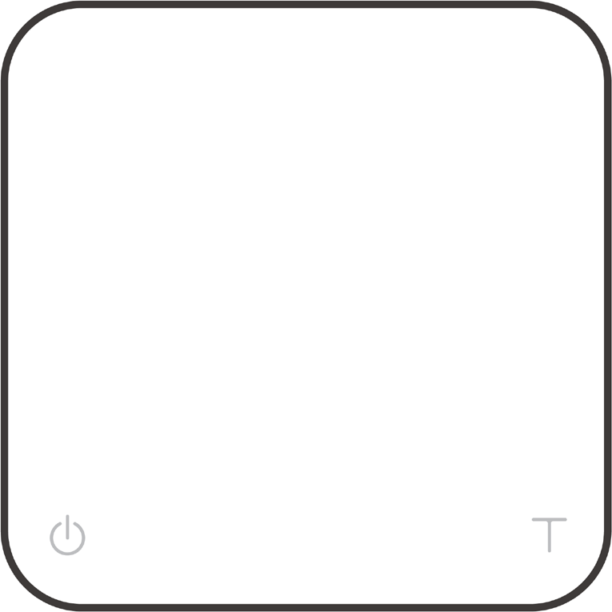

Buttons

 | Function | Example
Power Button   | Turn on | Tap to turn on the scale.
 | Turn off | Double tap to turn off the scale.
 | Switch Mode | While the scale is turned on, press and hold for one second to switch modes.
 | Advanced Settings | When the scale is turned off, press and hold to enter Settings.
 | Start / Stop / Reset Timer | Tap to start / stop / reset timer.
 | Back | While in Settings Menu, double tap to go back to Modes.
Tare Button   | Tare | Tap to perform tare operation.
 | Switch between Grams / Ounces | Press and hold to switch weighing unit between grams and ounces.
 | Switch options | While in Settings, tap to advance through settings options. While in settings, tap to switch options in sub menus.
 | Reset | Double tap to reset a mode. This zeroes the weight and sets the timer to 0:00.
 | Confirm | While in Settings, press and hold for two seconds to confirm the option selected in a sub menu.
 | Enter Calibration Mode | While in Weighing Mode, set the unit to grams and rapidly tap to enter Calibration Mode.

LED Indicators

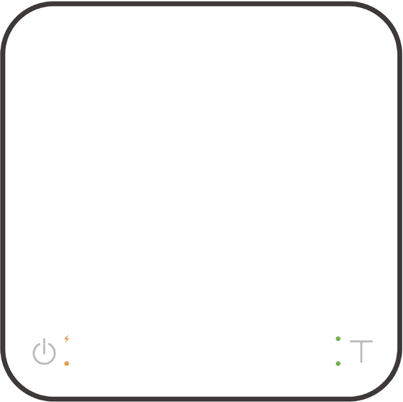Battery Charge / Low Battery Indicator

Bluetooth Connection Indicator / Button Pressed

Weighing in Ounces Weight Stable Indicator

Battery Charge / Low Battery Indicator
This indicator turns on when the battery is charging and turns off once the battery is fully charged. The indicator starts flashing when the battery power is low as a reminder to charge the scale.

* Note: The Acaia Pearl Model S is equipped with charging protection to prevent the battery from charging under high temperatures. It is normal if the scale does not charge when the surface is hot from brewing coffee. Battery charging function will be enabled once the scale has cooled.

Bluetooth Connection Indicator / Button Pressed
The orange indicator on the lower left turns on when the Tare button is pressed.

Weighing in Ounces
The green indicator on the upper right turns on when the weight is measured in ounces.

Weight Stable Indicator
If Weight Stable Indicator setting is on, the green indicator on the lower right turns on when the weight is stable.

Error Codes

Error Code | Description
Error 100 | Access Code Error, unrecognized access code.
Error 101 | EEPROM error, unable to access memory. Please contact Acaia support.
Error 102 | AD error, unable to access weighing signal. Please contact Acaia support.
Error 303 | Unable to find acceptable starting Zero point, most likely because the loadcell has been damaged by excessive force or drop. Please contact Acaia support.
Maximum | Overload: the weight is over the maximum capacity.
Underload | Underload: the weight is under the minimum capacity.
Error 304 | Calibration error. Calibration cannot proceed when environmental noises are too strong. Please calibrate in a stable environment free of wind, vibration, etc.
Error 802 | Unable to tare because the weight exceeds the acceptable tare range.
Error 803 | Unable to tare because the weight is unstable.
Other

Display Code | Description
UPDATE | The scale is in update mode. During the update process, the green LED on the lower right will blink until the process is complete.  Note: If you want to leave update mode, please connect the scale’s USB to a power source.

Specifications

Model | PS003 / PS004
Product Weight | 620 g ± 5 g
Product Dimensions | W: 160 mm L: 160 mm H: 32 mm
Maximum Capacity | 3000 g / 105.82 oz
Minimum Weight | 0.1 g
Measuring Units | Grams, Ounces
Readability | 0.1 g
Repeatability | 0.1 g
Linearity | 1 d (d = 0.1 g / 0.5 g)
Indication Limit | 3090 g / 108.99 oz
Power Supply | 5 V / 500 mA
Battery | Lithium-ion rechargeable 3.7 V 2200 mAh
Battery Life | Up to 16~40 hours
Display | Dot matrix LED
Material | PC
Connectivity | Bluetooth 5.0
Warranty | 1 Year
Inside the Package | Acaia Pearl Model S Coffee Scale (White / Black) x 1 Heat Resistant Coaster (Round) x 1  USB Type-C Charger Cable x 1

Copyright

This user manual is protected by copyright. All rights reserved. No part of this manual may be reproduced, processed, duplicated or published in any form by photocopying, microfilming, reprinting or any other method, in particular electronic means, without the written consent of Acaia.

© Acaia, California, 2023.

